Q11. Read the following description of an assembler program and the program itself, and then answer sub-questions 1 and 2.

[Program Description]
This is a subprogram group that manages reserved seats in a movie theater. The movie theater has 1,024 reserved seats, numbered from 0 to 1023. The subprograms include INIT, which initializes the seat reservation table RSVTBL; RESERVE, which reserves a seat; and CANCEL, which cancels a reserved seat. The structure of the seat reservation table, which stores the status of each reserved seat, is shown in the figure below.

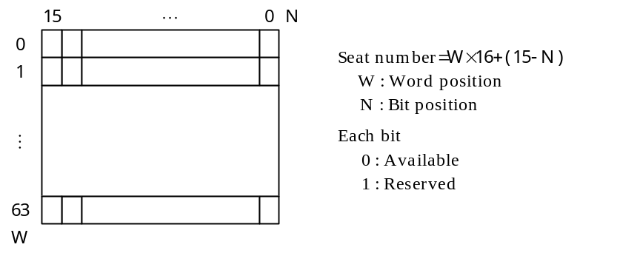
Fig. Seat Reservation Table RSVTBL

(1) The subprogram INIT sets all of the bits in the seat reservation table to the “available” state.
(2) The subprogram RESERVE reserves one seat. The subprogram searches through the seats, starting from seat 0, until it finds an “available” seat, and then changes the status of that seat to “reserved” and stores the seat number in GR0. If all of the seats are already reserved, the subprogram stores the value “−1” in GR0.
(3) The subprogram CANCEL cancels the reservation of the seat number that is specified by GR1. After confirming that the status of the specified seat is “reserved,” the subprogram changes the status to “available.” If the cancellation processing ends normally, the subprogram stores the value “0” in GR0. If there is an error in the seat number specification, or if the seat specified by the seat number is already in the “available” state, the subprogram stores the value “−1” in GR0.
(4) Except for GR0, the contents of all the general-purpose registers that are used by the subprograms are saved.
(5) The functions of the RPUSH and RPOP macro instructions used in the program are as described below:
RPUSH : Saves the contents of GR1 through GR7 into the stack.
RPOP : Restores the contents of the stack into GR1 through GR7.
[Program]

MAIN START
·
·
·
; Initializes the seat reservation table
INIT PUSH 0,GR1
LD GR1,RSVTBLSZ
LAD GR0,0
CLEARP LAD GR1,−1,GR1
 ; 0 → RSVTBL
LD GR1,GR1
JNZ CLEARP
POP GR1
RET
; Reserves a seat
RESERVE RPUSH
LAD GR2,0
LD GR0,GR2
RSV01 LD GR1,RSVTBL,GR2
 ; Are 16 seats all reserved?
JZE RSV03
LAD GR3,#8000
RSV02 LD GR4,GR1
AND GR4,GR3 ; Checks reservation status of each seat
JZE RSV04
ADDL GR0,=1
 ; Prepares for next seat
JUMP RSV02
RSV03 ADDL GR0,=16
LAD GR2,1,GR2
CPL GR2,RSVTBLSZ
JNZ RSV01
 ; No available seats
JUMP RRET
RSV04 OR GR1,GR3
ST GR1,RSVTBL,GR2
RRET RPOP
RET
; Cancels a reserved seat
CANCEL RPUSH
LD GR2,GR1
 ; Determines word position
CPL GR1,RSVTBLSZ
JPL CERROR
JZE CERROR
LAD GR1,RSVTBL,GR1
AND GR2,=#000F
LAD GR3,#8000
SRL GR3,0,GR2 ; Determines bit position
LD GR0,0,GR1
AND GR0,GR3
JZE CERROR
 ; Inverts the bits
LD GR0,0,GR1
AND GR0,GR3
ST GR0,0,GR1
LAD GR0,0
JUMP CRET
CERROR LAD GR0,−1
CRET RPOP
RET
;
RSVTBLSZ DC 64 ; Size of reservation table
RSVTBL DS 64 ; Reservation table
END

Sub-question 1
From the answer groups below, select the correct answers to be inserted in the boxes  in the program.

Answer group for “a”:
a) ST GR0,0,GR1 b) ST GR0,RSVTBL,GR1
c) ST GR1,0,GR1 d) ST GR1,RSVTBL,GR1
e) ST GR2,0,GR1 f) ST GR2,RSVTBL,GR1

Answer group for “b”:
a) CPL GR0,−1 b) CPL GR0,=0 c) CPL GR0,=#FFFF
d) CPL GR1,−1 e) CPL GR1,=0 f) CPL GR1,=#FFFF

Answer group for “c” and “e”:
a) SLL GR1,1 b) SLL GR1,4 c) SLL GR3,1
d) SLL GR3,4 e) SRL GR1,1 f) SRL GR1,4
g) SRL GR3,1 h) SRL GR3,4

Answer group for “d”:
a) LAD GR0,−1 b) LAD GR1,−1 c) LD GR0,−1
d) LD GR1,−1

Answer group for “f”:
a) AND GR3,−1 b) AND GR3,=#FFFF c) OR GR3,−1
d) OR GR3,=#FFFF e) XOR GR3,−1 f) XOR GR3,=#FFFF
Sub-question 2
The locations labeled α and β in the program are changed as shown below. From the answer group below, select the maximum number of reserved seats that can be handled by this program as a result of this change.

RSVTBLSZ DC 120 ; Size of reservation table
RSVTBL DS 120 ; Reservation table

Answer group:
a) 960 b) 1,440 c) 1,920
d) 2,400 e) 2,880

